ENZYMES REVISION MK Q32 2013

1. Using the lock and key model, name the following molecules (3 marks) B:

A and C: ABC:

|  |  |
| --- | --- |
| **Description** | **Marks** |
| B – Enzyme | 1 |
| A and C – Substrates | 1 |
| ABC - Complex/ Enzyme substrate complex | 1 |
| **Total** | **3** |

1. On the diagram above, draw a circle around the active site. (1 mark)

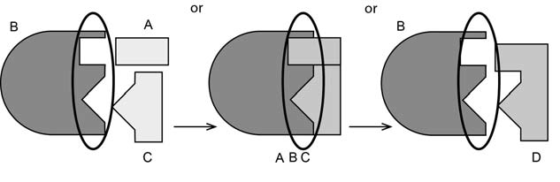

**Description**

Circle around active site on structure B (can be on any of the three B structures in the diagram)

**Marks**

For copyright reasons this image cannot be reproduced in the online

version of this document but may be viewed at [www.hi.com.au/resource/science/fullImg.asp?imageid=12694&age=2&subt](http://www.hi.com.au/resource/science/fullImg.asp?imageid=12694&amp;age=2&amp;subt) opicid=1320&kla=1

1

**Total**

**1**

1. Describe the rate of reaction as temperature increases.(3 marks) Before 40 ºC:

At 40 ºC:

After 40 ºC:

|  |  |
| --- | --- |
| **Description** | **Marks** |
| Before - steadily increases | 1 |
| At - rapidly starts to decrease/ highest point/ reaches peak | 1 |
| After – continues to decrease/ slowly starts to increase again | 1 |
| **Total** | **3** |

1. Complete the following sentences relating to the reaction shown in the graph. (3 marks) The activation energy of a reaction is the energy required to a chemical reaction. The rate of the reaction up until 40 ºC has been altered by the presence of an enzyme. The enzyme has worked to the activation energy of the reaction. After 40 ºC the reaction rate has changed

because the heat has caused the to change shape.

|  |  |
| --- | --- |
| **Description** | **Marks** |
| Start | 1 |
| Lower | 1 |
| Active site/ protein/ enzyme | 1 |
| **Total** | **3** |